System Requirement Specification

# Document Tracking

The following chart is used to log of all changes made to this document.

| **Version** | **Date Modified** | **Modified By** | **Description of modification** |
| --- | --- | --- | --- |
| 1.0 | 27-11-2017 | Horizon2020 team | Initial draft version |
| 2.0 | 19-01-2018 | Horizon2020 team | Revised version(final) |
| 3.0 | xx-xx-xxxx | XXXX | XXXX |

# 

**Table of Contents**

Document Tracking 1

Project Overview 3

Objective 3

Business Case 3

Descriptive analysis:- 3

Comparative analysis:- 4

Predictive analysis:- 4

Risks 4

Out of Scope 4

Technical Design Diagram 5

Technical Specifications 6

Hardware & Software Requirements 6

File Servers 7

Web Servers 7

Data Visualization 7

# Project Overview

* The last few decades has seen a big increase in India’s population owing to better health care , ever expanding economy and a stable administration . There has been noticeable movement of masses from rural heartland to bigger cities in search of better opportunities. As such, there has been a greater focus to carry out independent comprehensive study on the crime pattern in changing times and demography which would in turn provide more visibility and awareness for initiating corrective and precautionary measures.
* Horizon 20-20 aims at taking a closer look and doing a in-depth-study at the current crime patterns, possible factors and investigating the possibility to predict criminal events for specific areas. The application will make use of new generation software technologies as ML and Big Data tools to analyze and predict.

# Objective

* Objectives are stated below:-
* Descriptive summary of crime patterns region-wise.
* Groupings of high disturbed, moderate disturbed and low disturbed regions.
* Prediction of criminal activities for specific regions
* Comparative study of criminal activities over the years (decline/increase)
* The output will be in form of graphical representation for quick and easier understanding.

# Business Case

Post liberalization, India is experiencing evolution of bigger cities. While this brings a lot of economic and social benefits, it comes with the additional challenge of maintaining a healthy law and order for the city to attract diverse talents from all around.

The application aims at providing a extensive statistical analysis for multiple regions and with varying segments of criminal activity that would serve as a single window platform for end users to deduce, earmark and choose safer place.

Below are some of the problem statements which the application aims to addresses:

# Descriptive analysis:-

* District/City wise analysis
* State wise analysis
* Nature and density of crime in a particular locality for people to take corrective and precautionary measures.
* Overall crime awareness for an immigrant to a new city (depending on the data the person can take measures to choose and reside in a locality of his/her choice.
* Administration efficacy in dealing with criminal incidents (how efficiently police functions in a district/state).
* Crime against women.
* Crime against oppressed classes.

# Comparative analysis:-

* District wise
* State wise
* Crime against women vs. all cases
* Crime against oppressed classes vs. crime against general class
* Number of conviction under trials vs. no. of cases.
* Crime by Juvenile vs. regular cases

# Predictive analysis:-

* District wise crime
* State wise crime
* Graphical representation of the data predicting the future trend taking an account of the current trend that can be used by law enforcing agencies and media.
* Future prediction of crime against oppressed classes with respect to current scenario.

# Risks

* Availability of software for project development.
* Accuracy of data available
* System Dependency

# Out of Scope

* Any data which is not published by the govt. will not be a part of this analysis.

# 

# Technical Design Diagram

Diagram is listed below:-

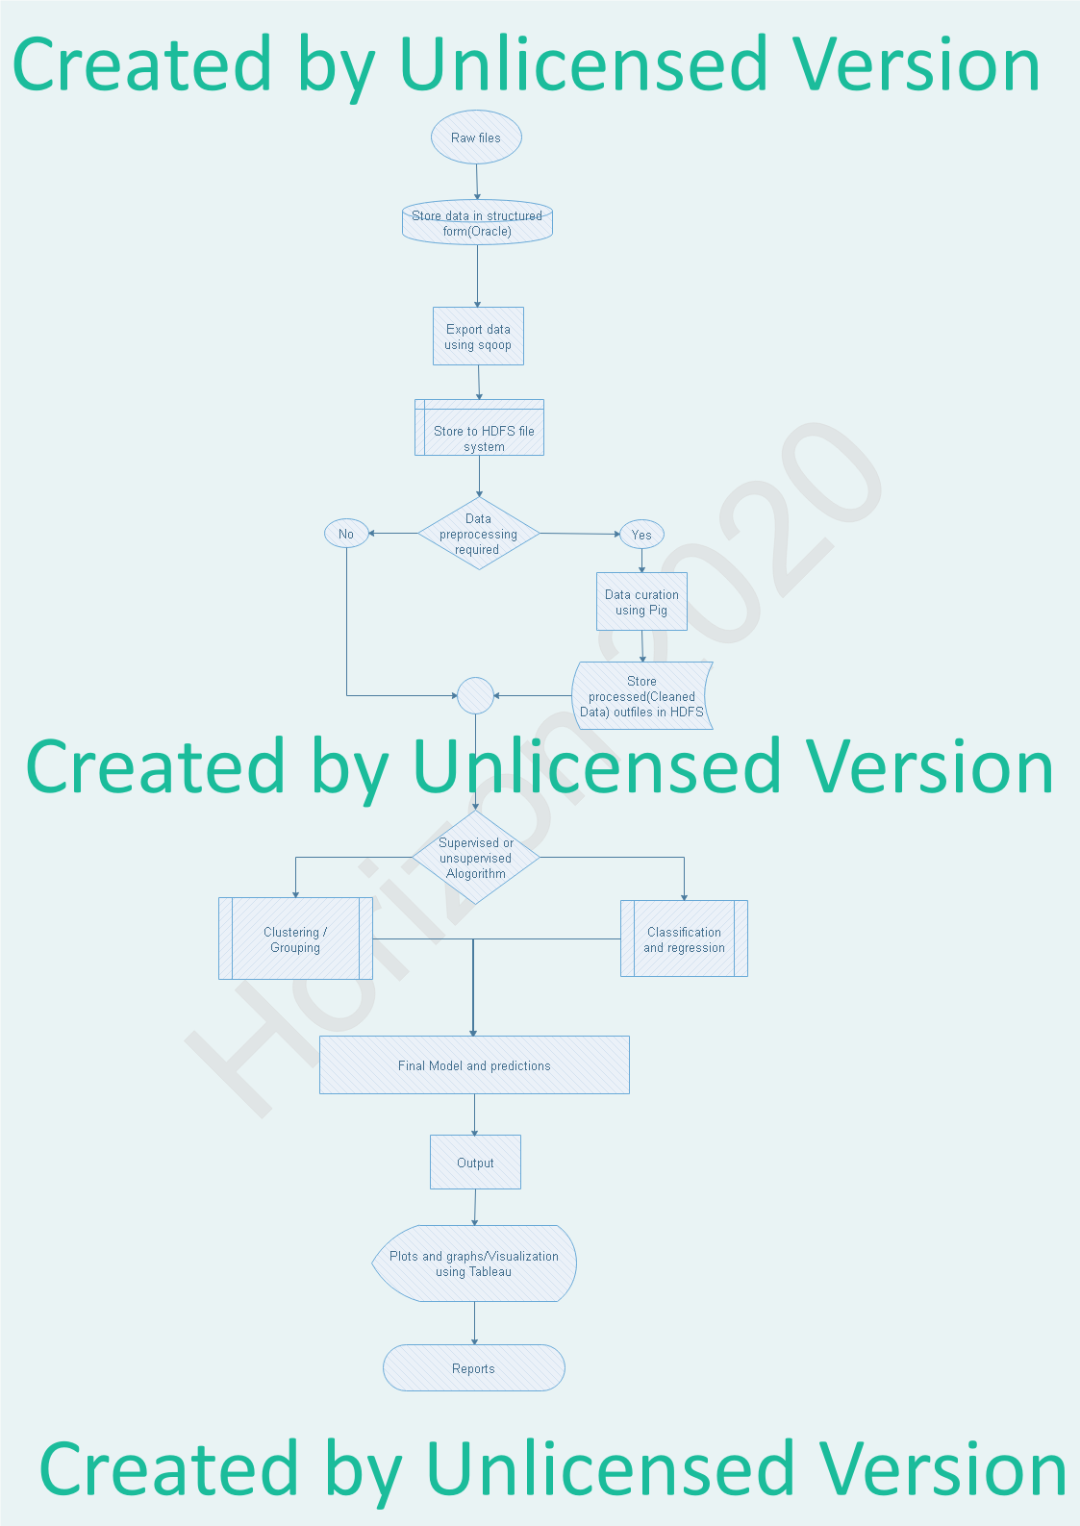

# Technical Specifications

## Hardware & Software Requirements

* Under the appropriate heading (3.1.1 through 3.1.4 below), list a brief description and function for each server that is needed, and include the following information:
* Windows and Linux
* 8 GB RAM
* Core2Duo successors

## File Servers

* Hadoop File System (HDFS)

## Web Servers

* Apache 2 Web Server (Hadoop Inbuilt)

Data Processing Tool

* Python Pandas

Data Analysis Tool

* Machine Learning With Python

## Data Visualization

* Tableau Public
* Python Matplotlib